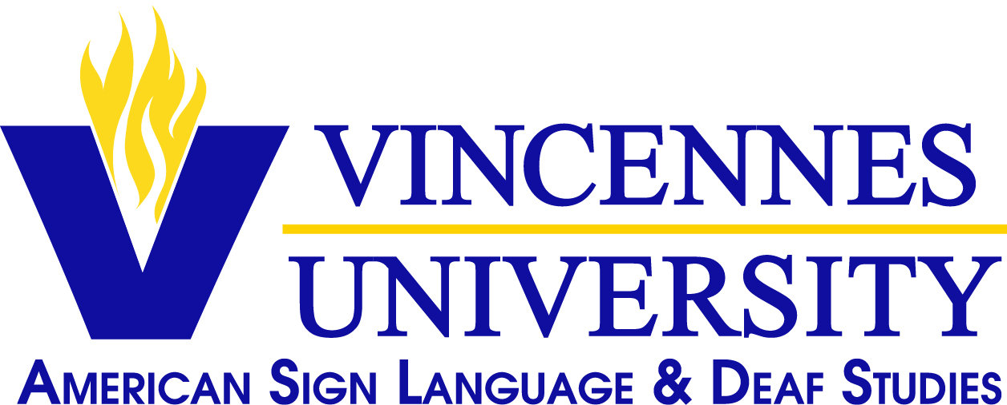
Summer 2018 Course Offerings
American Sign Language Studies Program
Vincennes University

Please view calendar and make sure these dates will work with your work/vacation schedule before signing up for the class.

Current students: Please check your payment status to make sure you are eligible to register for classes. The bill must be paid in full.

Students returning after being out one semester must be reapplied first to VU and be paid in full.

Course & Sequence | CRN | Course Title | CR | Day | Time | Teacher | Session /Room
ASLG 101 DE | 50290 | ASL I | 4 | Online | Online | Sanders | 10 Week Session/ Online
ASLG 103 DE | 50291 | ASL II | 4 | Online | Online | Sanders | 10 Week Session/ Online
ASLG 210 I01 | 50957 | ASL Literature | 3 | See  Below | 1:00 – 5:00 PM | Conner | *See days and time below/  Room 236

*ASL Literature Meets: May 7, 8, 9, 10, 11, 14, 15, 16, 17, 21, 22
Important: Follow the dates and times of the classes listed here and not the dates and times shown on your registration print-out.

